

Soft computing project

Arab Academy for Science, Technology & Maritime Transport

May 17

College Of Computing & Information Technology
Presented by: Abdelrahman Ahmed 211013214
Presented to: Pro.Dr.Nashwa Elbendary



Table of Contents
ML algorithm 2
Using SVM and KNN 2
SVM (Support Vector Machine) 2
SVM Pseudocode 2
SVM flowchart 3
KNN (K-Nearest Neighbors) 3
KNN Pseudocode 4
KNN flowchart 5
Genetic Algorithm and Particle Swarm Optimization 5
Genetic Algorithm 5
Genetic Algorithm Pseudocode 6
Genetic Algorithm Flowchart 7
Particle Swarm Optimization (PSO) 8
PSO Pseudocode 8
PSO Flowchart 9
Dataset 10
Description 10
Source 10
Block diagram of the implemented system 11
Code 12
summarizing and comparing performance metrics 12
Accuracy 12
F1 score 13
Prediction Time 13
References 15

Figure 1 Support Vector Machine Pseudocode [2] 2
Figure 2 Support Vector Machine Flowchart [3] 3
Figure 3 K nearest neighbor Pseudocode [5] 4
Figure 4 K nearest neighbor flowchart [6] 5
Figure 5 Genetic Algorithm Pseudocode [8] 6
Figure 6 Genetic Algorithm Flowchart [9] 7
Figure 7 Particle Swarm Optimization Pseudocode [11] 8
Figure 8 Particle Swarm Optimization Flowchart [12] 9
Figure 9 Block diagram of the whole system implemented 11
Figure 10 Accuracy Performance Bar chart 12
Figure 11 F1-score measure performance Bar chart 13
Figure 12 Prediction time comparison 13

Introduction
Surface quality control in stainless steel manufacturing is critical for ensuring product reliability and aesthetic standards. The Steel Plates Faults dataset, originating from the Semeion Research Center and commissioned by Italy’s Centro Sviluppo Materiali, comprises geometric descriptors of various surface irregularities. [1] Although the precise nature of the 27 input indicators remains proprietary, they collectively capture shape and outline characteristics of defects. The primary objective of this study is to evaluate three feature‐processing strategies—using all raw indicators, employing a Genetic Algorithm (GA) for feature selection, and leveraging Particle Swarm Optimization (PSO) for feature reduction—across two classifiers, Support Vector Machines (SVM) and K-Nearest Neighbors (KNN). Performance metrics include weighted F1 score and overall accuracy, complemented by training and prediction times, to assess both effectiveness and computational efficiency. Initial experiments with the full feature set establish a baseline, while subsequent GA and PSO experiments investigate the trade-off between dimensionality reduction and classification performance. [2] Comparative analysis focuses on identifying whether feature selection can maintain, or even improve, predictive accuracy while reducing model complexity. Findings aim to guide future efforts in automated surface defect detection, balancing model interpretability and operational speed in industrial inspection systems. [3]

ML algorithm

Using SVM and KNN

SVM (Support Vector Machine)
SVM is a supervised learning algorithm used for classification and regression. It works by finding the optimal hyperplane that maximizes the margin between different classes in the feature space. SVM can handle both linear and non-linear classification using kernel tricks. [1]

SVM Pseudocode
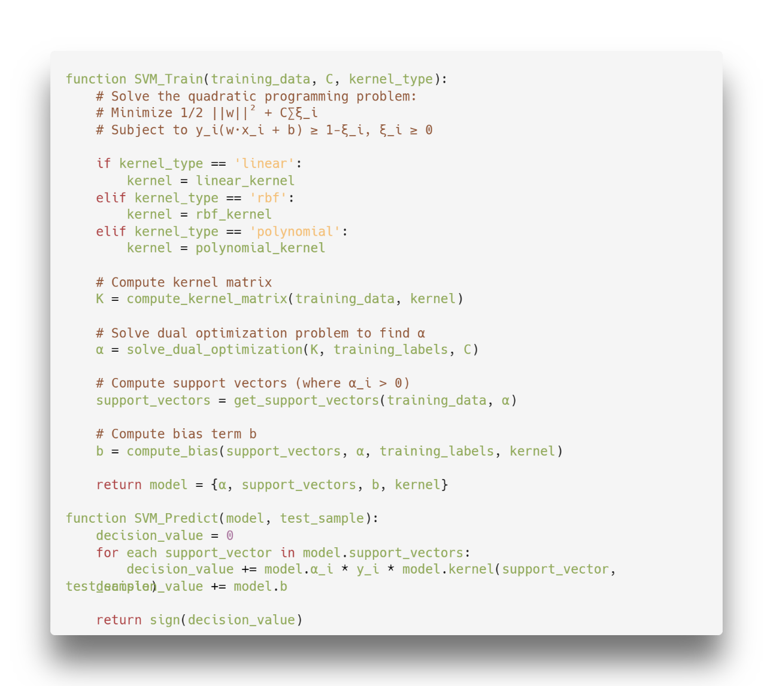
Figure 1 Support Vector Machine Pseudocode [2]

SVM flowchart
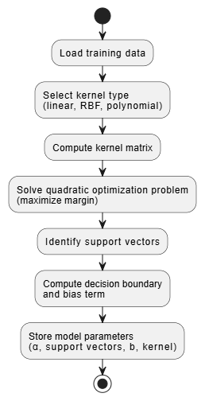
Figure 2 Support Vector Machine Flowchart [3]

KNN (K-Nearest Neighbors)
KNN is a simple, instance-based learning algorithm that classifies new data points based on the majority class of their k nearest neighbors in the feature space. It's a lazy learner as it doesn't build a model during training but stores all training data. [4]

KNN Pseudocode
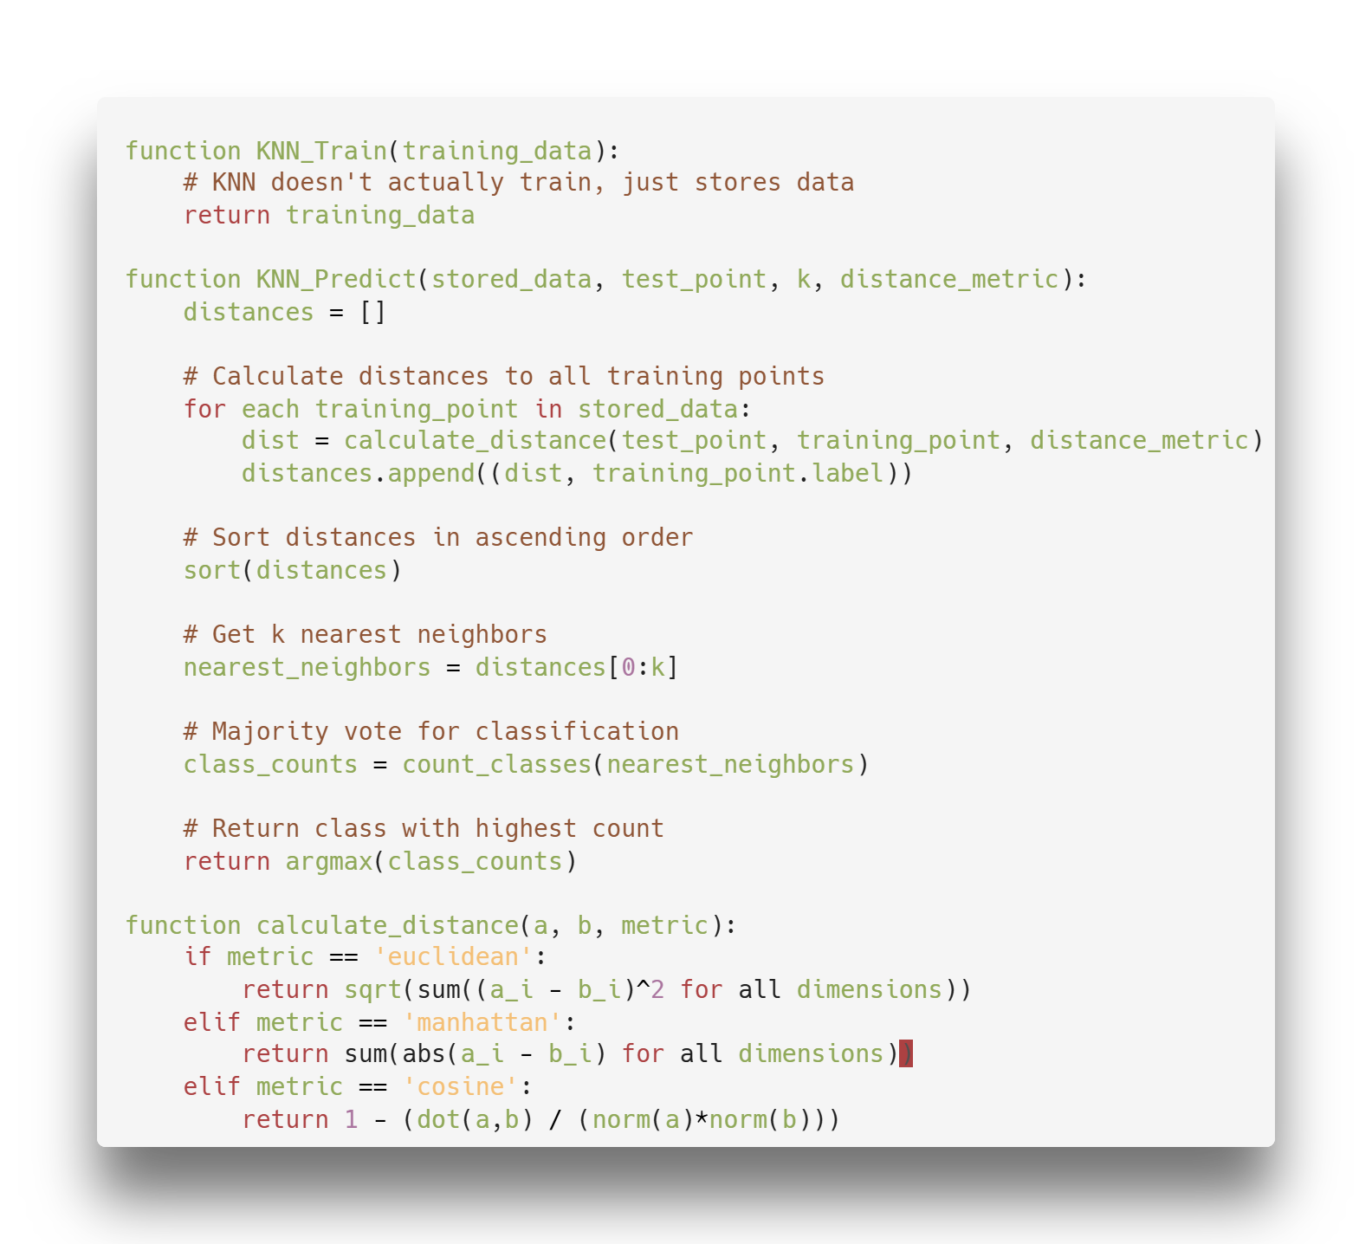
Figure 3 K nearest neighbor Pseudocode [5]

KNN flowchart
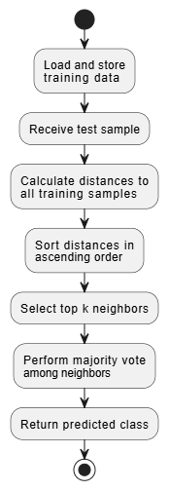
Figure 4 K nearest neighbor flowchart [6]

Genetic Algorithm and Particle Swarm Optimization

Genetic Algorithm
GA is a metaheuristic inspired by the process of natural selection that belongs to the larger class of evolutionary algorithms. It uses techniques inspired by biological evolution such as selection, crossover, and mutation. [7]

Genetic Algorithm Pseudocode
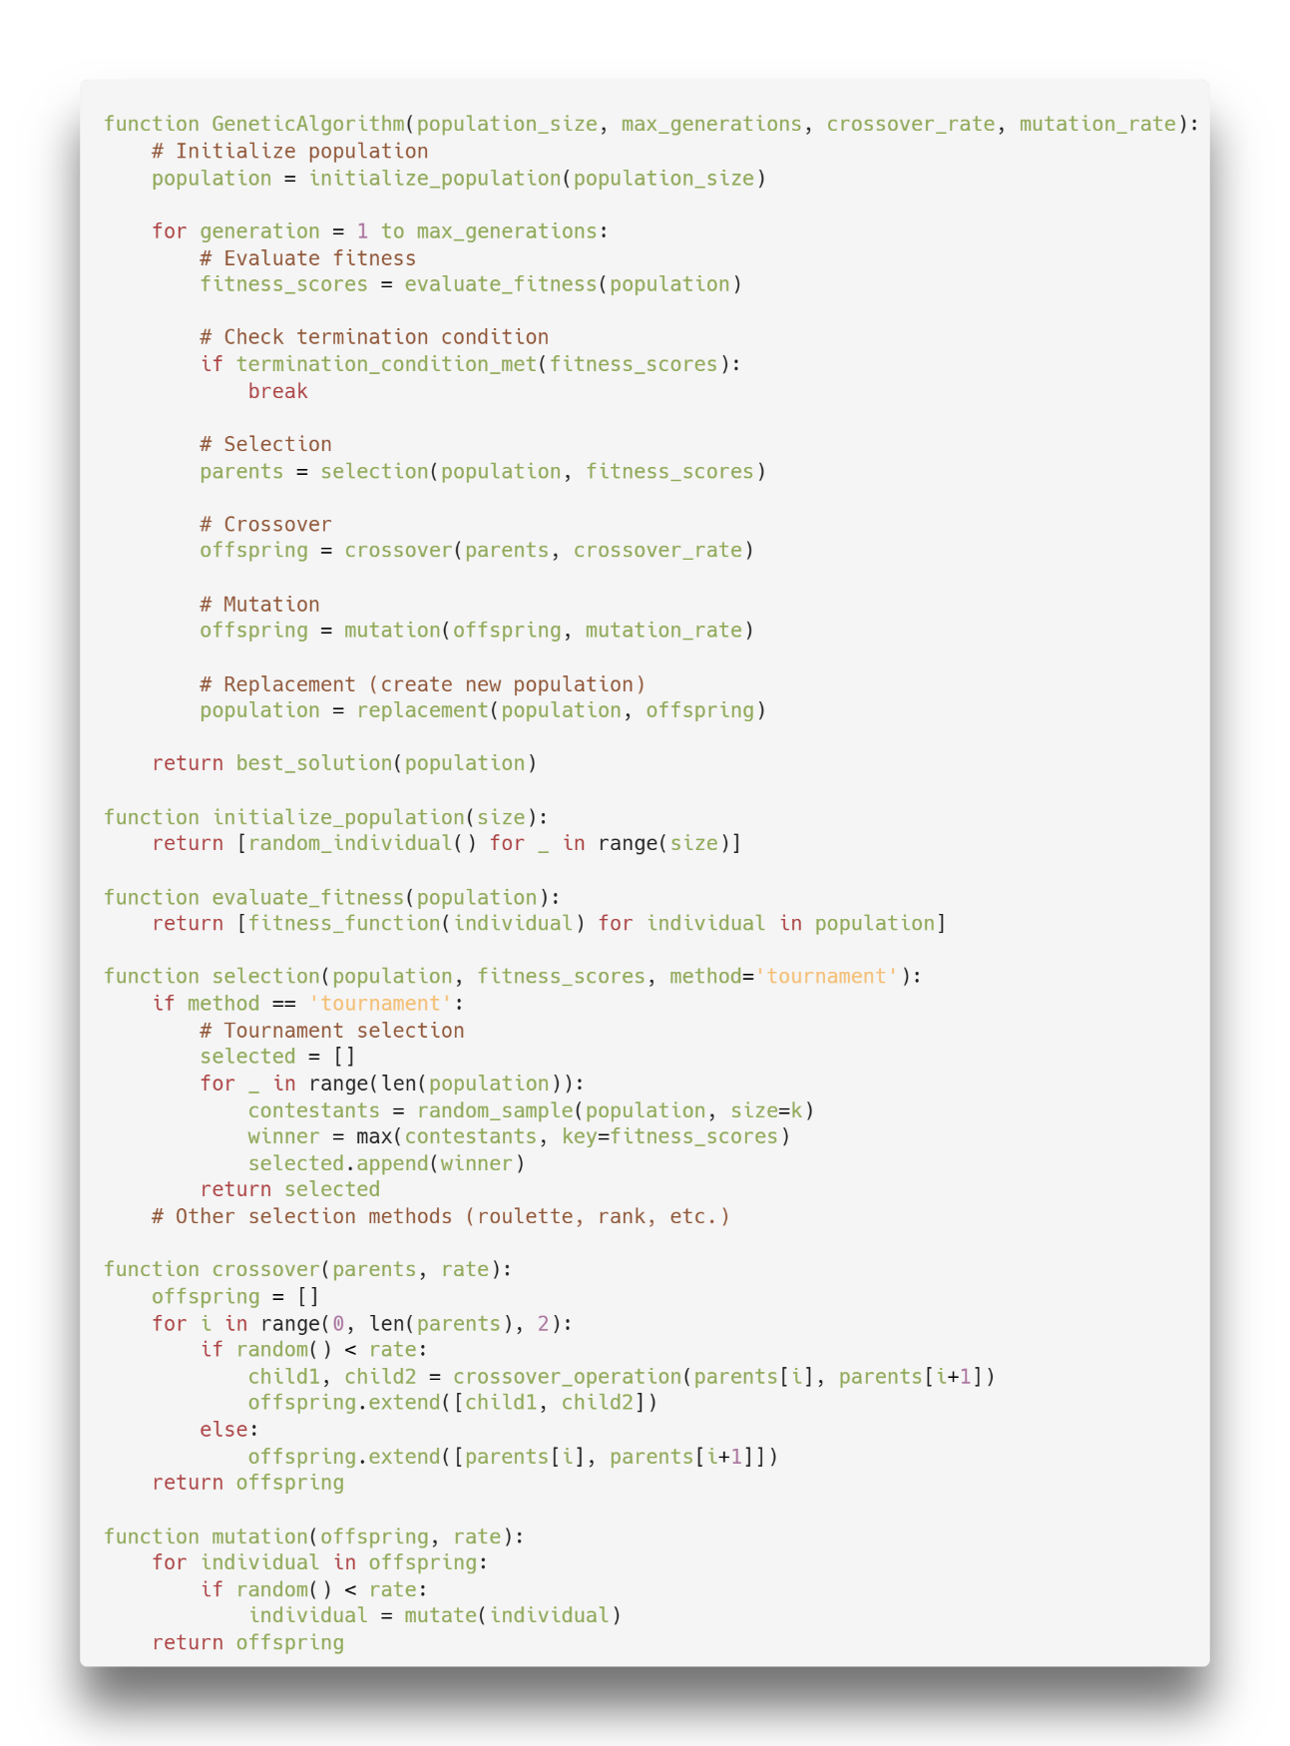
Figure 5 Genetic Algorithm Pseudocode [8]

Genetic Algorithm Flowchart
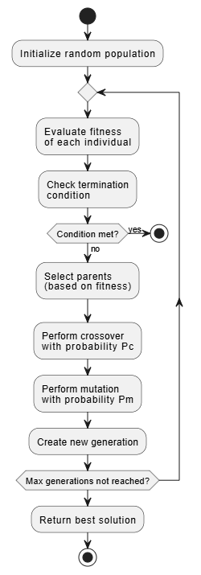
Figure 6 Genetic Algorithm Flowchart [9]

Particle Swarm Optimization (PSO)
PSO is a population-based optimization technique inspired by the social behavior of bird flocking or fish schooling. Each particle adjusts its position based on its own experience and that of its neighbors. [10]

PSO Pseudocode
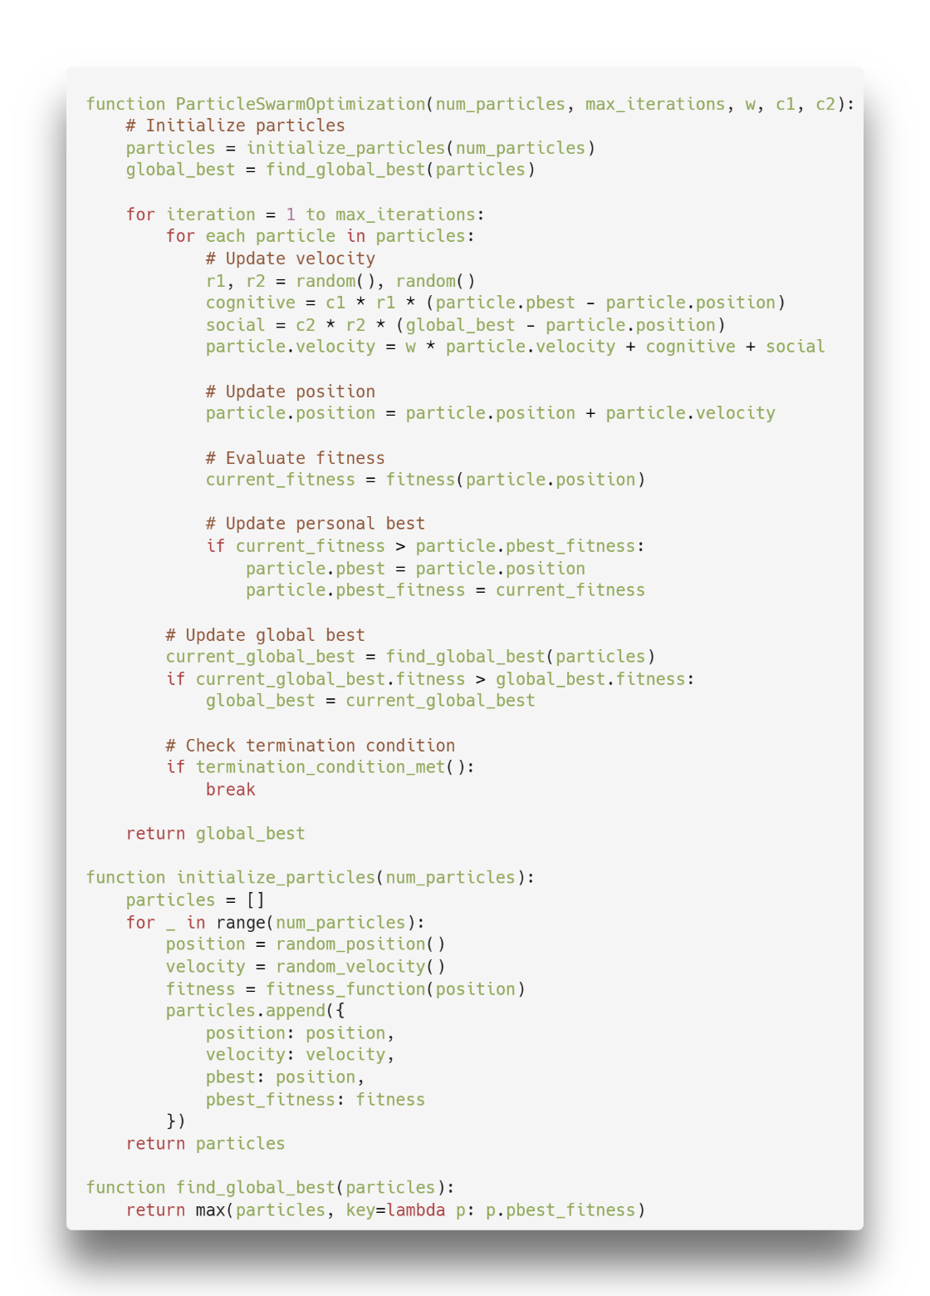
Figure 7 Particle Swarm Optimization Pseudocode [11]

PSO Flowchart
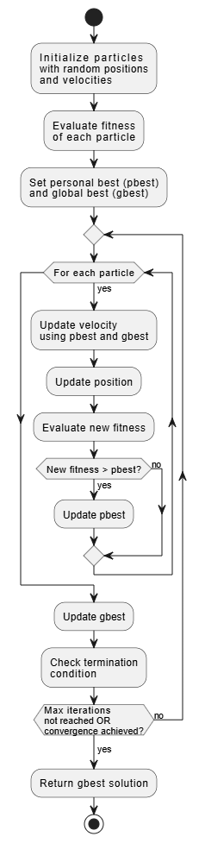
Figure 8 Particle Swarm Optimization Flowchart [12]

Dataset

Description
This dataset comes from research by Semeion, Research Center of Sciences of Communication. The original aim of the research was to correctly classify the type of surface defects in stainless steel plates, with six types of possible defects (plus "other"). The Input vector was made up of 27 indicators that approximately [describe] the geometric shape of the defect and its outline. According to the research paper, Semeion was commissioned by the Centro Sviluppo Materiali (Italy) for this task and therefore it is not possible to provide details on the nature of the 27 indicators used as Input vectors or the types of the 6 classes of defects. [13]

Source
The dataset is located at Kaggle
https://www.kaggle.com/datasets/sureshmecad/steel-plates-faults/data

Block diagram of the implemented system
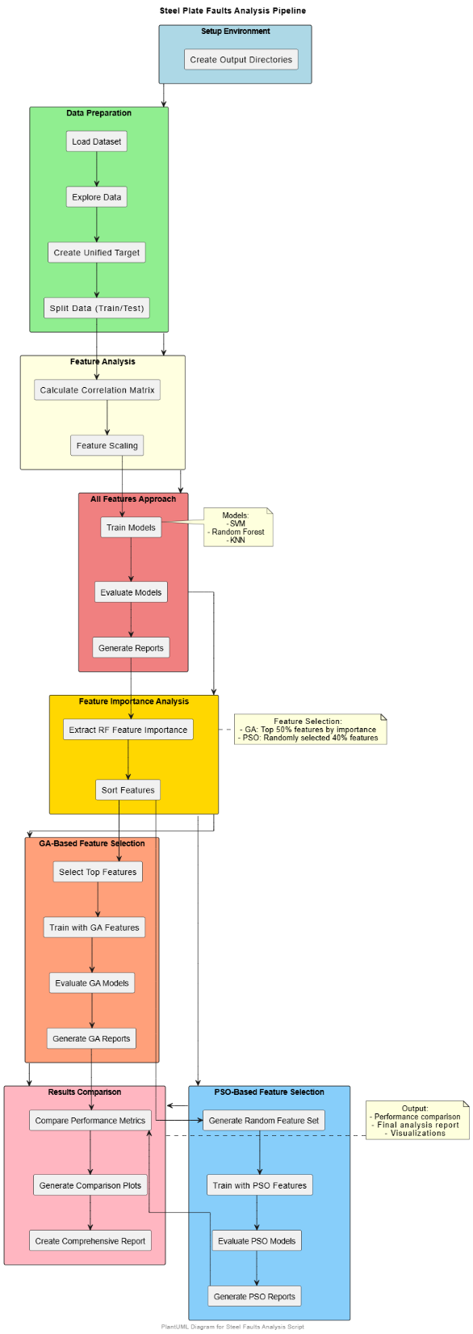
Figure 9 Block diagram of the whole system implemented

Code
Here is a GitHub URL to the source code:
https://github.com/DevAbdoTolba/Soft-computing-project

summarizing and comparing performance metrics

Accuracy
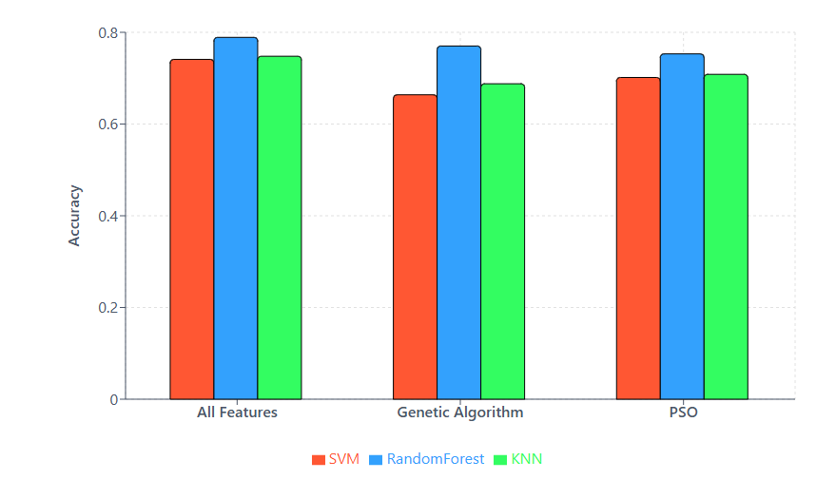
Figure 10 Accuracy Performance Bar chart

F1 score
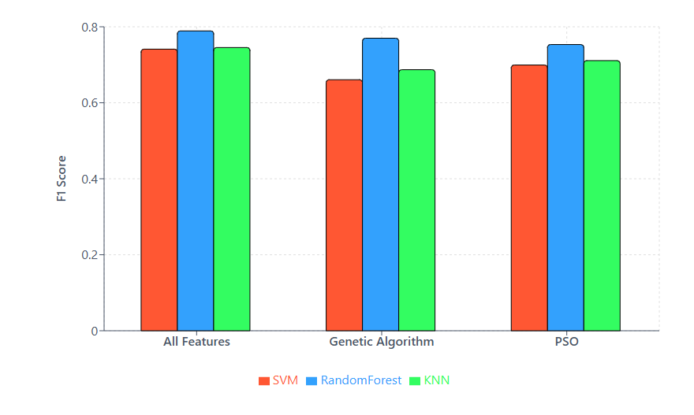
Figure 11 F1-score measure performance Bar chart

Prediction Time
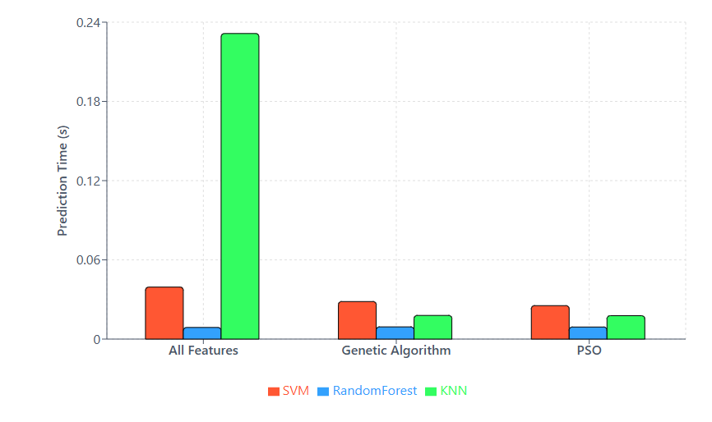
Figure 12 Prediction time comparison

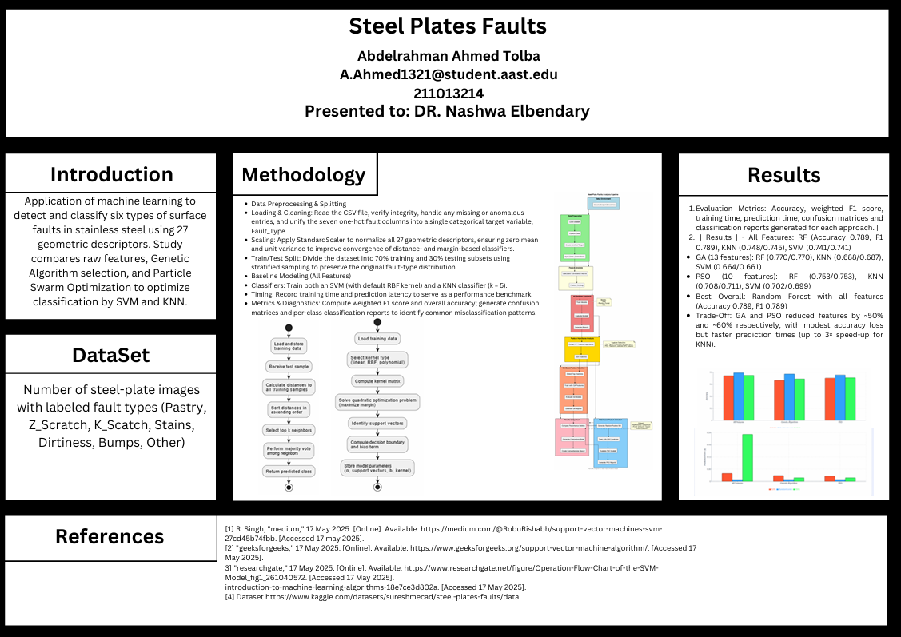

Youtube link:
https://youtu.be/Wrc1aoJPDU0
Github link:
https://github.com/DevAbdoTolba/Soft-computing-project
Dataset link:
https://www.kaggle.com/datasets/sureshmecad/steel-plates-faults/data

References

[1] | R. Singh, "medium," 17 May 2025. [Online]. Available: https://medium.com/@RobuRishabh/support-vector-machines-svm-27cd45b74fbb. [Accessed 17 may 2025].
[2] | "geeksforgeeks," 17 May 2025. [Online]. Available: https://www.geeksforgeeks.org/support-vector-machine-algorithm/. [Accessed 17 May 2025].
[3] | "researchgate," 17 May 2025. [Online]. Available: https://www.researchgate.net/figure/Operation-Flow-Chart-of-the-SVM-Model_fig1_261040572. [Accessed 17 May 2025].
[4] | "https://medium.com/swlh/k-nearest-neighbor-ca2593d7a3c4," 17 May 2025. [Online]. Available: https://medium.com/swlh/k-nearest-neighbor-ca2593d7a3c4. [Accessed 17 May 2025].
[5] | "medium," [Online]. Available: https://medium.com/data-science/k-nearest-neighbours-introduction-to-machine-learning-algorithms-18e7ce3d802a. [Accessed 17 May 2025].
[6] | "medium," [Online]. Available: https://medium.com/data-science/knn-algorithm-from-scratch-37febe0c15b3. [Accessed 17 May 2025].
[7] | "mathworks," [Online]. Available: https://www.mathworks.com/help/gads/what-is-the-genetic-algorithm.html. [Accessed 17 May 2025].
[8] | "cs.cmu.edu," [Online]. Available: https://www.cs.cmu.edu/Groups/AI/html/faqs/ai/genetic/part2/faq-doc-2.html. [Accessed 17 May 2025].
[9] | "researchgate," [Online]. Available: https://www.researchgate.net/figure/Flowchart-of-the-standard-genetic-algorithm-GA-33_fig1_344832850. [Accessed 17 May 2025].
[10] | "machinelearningmastery," [Online]. Available: https://machinelearningmastery.com/a-gentle-introduction-to-particle-swarm-optimization/. [Accessed 17 May 2025].
[11] | "researchgate," [Online]. Available: https://www.researchgate.net/figure/Pseudocode-of-standard-particle-swarm-optimization_fig1_323281605. [Accessed 17 May 2025].
[12] | "researchgate," [Online]. Available: https://www.researchgate.net/figure/Particle-swarm-optimization-flowchart_fig1_252629792. [Accessed 17 May 2025].
[13] | "Kaggle," [Online]. Available: https://www.kaggle.com/datasets/sureshmecad/steel-plates-faults/data. [Accessed 17 May 2025].

